ABSTRACT

INTRODUCTION: Clinical rotations (CR) are the core of teaching and learning process of Internal Medicine (IM) residency programmes. Feedback about CR identifies which aspects are deficient and need improvement. However, during curricular improvement processes, difficulties prioritising these improvements emerge.

AIM: To explore residents’ and clinical teachers’ perceptions about which aspects constitute a high-quality CR in an IM programme.

METHODS: Qualitative methodology was used. Data were obtained from two focus groups (residents and clinical teachers, separately) and from open-ended responses collected from CR questionnaire instrument. Data were analysed with ATLAS.ti software using grounded theory methodology.

RESULTS: Two focus groups and ninety-eight open-ended questions were analysed. Eight themes and thirty-two categories emerged from residents’ and clinical teachers’ perspectives: ‘Learning & Feedback’, ‘Learning assessment’, ‘Clinical Teachers: Roles & Characteristics’, ‘Scholar: Specialty Knowledge & Skills’, ‘Clinical Teaching rounds’, ‘CR Organisation’, and ‘Learning Environment’ were themes with common ground in both groups. ‘IM Programme Committee’ emerged as a theme exclusively on residents’ perspectives.

CONCLUSIONS Residents’ and teachers' perspectives are central to identifying issues that help CR improvement. Both groups agree on most aspects. An IM clinical rotation framework is proposed, based on eight themes that emerged. IM Programme Committee should have an articulating role among CR to assure high-quality teaching.
INTRODUCTION

The field of medicine gains more complexity as time passes, consequently, highly trained doctors on technical and professional skills are required. Internal Medicine (IM) residents must acquire theoretical knowledge and competencies for effective patient-centred care, with the ability to manage the broad spectrum of disease that affects adult patients (1). To accomplish this goal, residents need a well-structured curriculum with continuous programme evaluation through different processes (2). IM programmes need to focus on how to transition knowledge to clinical practice. One mechanism to make this transition is through clinical rotations (CR), where practical experience, teaching and learning activities, and workplace-based assessment (3) is tied to everyday medicine complexity (4).

Most residency programmes are seeking solutions to enhance their teaching and learning methodology with the use of accurate evaluation instruments (5). However, it is a complex task to evaluate CR, given the entanglement of factors beyond the clinical teaching skills involved. One of these factors is the clinical learning environment, which can impact either positively or negatively on the effectiveness of clinical rotations (6,7). It is mandatory to have a comprehensive and bi-directional feedback approach and proper evaluation instruments (8,9). IM programmes should ensure residents' timely feedback, engage them in active learning, adapt to their learning styles, and make it relevant to their needs (10). These features are crucial for a successful adult learning process (11).

Several instruments help residents to evaluate their clinical teachers, such as Maastricht Clinical Teaching Questionnaire (12) or MEDUC-PG14 (13), regarding their teaching skills and their abilities to create a positive learning environment. However, evaluation instruments that allow learners to evaluate their CR thoroughly are scarce. The Internal Medicine Programme Instrument 15-items (IMPRINT-15) is one of them. It is a valid, reliable, and bi-dimensional assessment instrument (14). Even so, all items from these aforementioned instruments have the same weight and contribute equally to the global rating score. Therefore, the information provided by these instruments is limited to identify which aspects are more critical to residents when they appraise specific attributes from their CR.

The information about clinical learning experience from students' and teachers’ views are limited and mainly related to undergraduate medical education (15). To our knowledge, no other studies contrast perspectives regarding CR from postgraduate clinical teachers/supervisors and residents/learners.

This research is embedded within a current curriculum change at Pontificia Universidad Católica de Chile's (PUC) IM Residency Programme. In 2018, the residency programme committee identified CR evaluations as a deficient aspect that required intervention. One of the first steps to remediate this deficiency was to design a new evaluation instrument (14). This research comes as a second step towards the primary goal. The aim of this research was to explore residents’ and clinical teachers’ perceptions about which aspects constitute a high-quality CR in an IM residency programme to help the medical education community improve the quality of IM CR.

METHODS

Population & Setting
Every year, approximately 20-25 residents are enrolled in the PUC IM residency programme. During their three-year residency, they work in public and private institutions, three teaching hospitals, and three ambulatory care centres. IM core curriculum has twenty-three CR.

Focus Groups Design
Residents were selected from PGY 2 & 3, and recent IM graduates. Incoming PGY 1 trainees were not invited to focus groups because they had less than two months in their residency programme. Residents had different undergraduate education background and prior work experience. Teachers were chosen mainly from the IM department and some from other departments, with different degrees of teaching experience, and from public and private hospitals. None of the participants received any benefit in exchange.

Open-Ended Questions
IMPRINT-15’s open-ended questions responses from residents with at least four-month experience in residency were used in this study. PGY 1 trainees were included to ensure General Medicine Ward CR evaluation. This questionnaire is applied to evaluate IM CR and has two domains: ‘teaching & care activities’ and ‘evaluation & feedback’ (14). This anonymous mandatory questionnaire is answered at the end of every 4-week CR, but responses from open-ended questions are not mandatory.

Subjects and Procedure
One expert in qualitative methodology conducted two focus groups: one with residents and another with clinical teachers. All participants signed a written consent form before every session. The expert was an external collaborator to guarantee confidentiality and unbiased analysis. Both focus groups were audiotaped and transcribed. Data from open-ended questions were obtained from IMPRINT-15. All data were processed anonymously. PUC´s scientific ethics committee approved this study (Id #190614033).

Qualitative Analysis
Data were analysed inductively using grounded theory approach (16-17). Initially, two investigators manually created categories as they emerged from the transcribed focus groups. ATLAS.ti software was used to support the categorisation and coding process. Then, open-ended questions responses analysis was made until thematic saturation was obtained (18-19). Data source and investigator triangulation were used in this study (20-21).
RESULTS

Data Collection
Both focus groups (FG) were implemented in July 2019. Eleven residents (91% acceptance rate) and five clinical teachers (36% acceptance rate) participated in a separate FG session. Table 1 summarises their characteristics.

Open-ended questions responses (O-EQR) were collected from IMPRINT-15 between August 2019 and February 2020. Two hundred ninety-eight questionnaires were analysed. Ninety-eight questionnaires (33%) had responses from open-ended questions. Twenty-seven (28%) were related to General Internal Medicine Ward and Intermediate Care Unit.

Data Analyses
The qualitative analysis was carried out based on focus group data. Twenty-eight categories emerged from this phase. Then, data from O-EQR were allocated sequentially into these categories. Four new categories emerged from this data source. At the end of this process, saturation was obtained. Figure 1 summarises the study phases and results from this study.

Eight themes and thirty-two categories emerged from residents’ and clinical teachers’ perspectives. All quotes were coded, identifying the subject (clinical teacher or resident) and information source (FG or O-EQR). Figure 2 summarises the themes and categories that emerged in this study.

Learning & Feedback
Residents and teachers shared the same view about this aspect and its relevance for an excellent CR. They mentioned that clinical teachers should actively pursue the learning and feedback process. A CR should be adapted to their needs with individualised learning:

‘He asked me what is it that I am interested in learning in this area and I focused my learning process on this so that it could be beneficial to me.’ (IM Graduate #8 - FG)

Both groups declared that learning objectives should be specific for their training year, measurable through learning assessment, and achievable in four weeks of CR. Also, learners’ value timely and precise feedback from their teachers.

‘…and when we have the feedback sessions, we compare the goals they set during the beginning of the CR. At this point, they realize they are failing to achieve the goals they previously set for themselves. This way it is easier for them to see.’ (Clinical Teacher #5 - FG)

Learning assessment
Residents appreciate clear rules about the assessment process. CR should have formal assessment opportunities, with the use of a wide range of assessment methods and adapted to the learner according to their level of residency. Residents acknowledge how assessment is essential to their development as future internists. Some of the issues they mentioned were how clinical teacher coordinators assessed their performance without an appropriate and direct workplace observation. This difficulty is frequent in CR with multiple clinical teachers.

‘…but the one that gives you the final grade never had a moment for you. So, he or she doesn’t assess you directly and perhaps just asks the others.’ (Resident PGY 3 #9 - FG)

In teachers’ narrative, they agreed with residents that the learning assessment should be according to resident PGY and done by their direct supervising clinical teacher.

‘One permanent problem is assessment tools. Sometimes you will find that some of these have 13 points and all of them have the same score (…) not all the points should count the same since some things are more important than others.’ (Clinical Teacher #4 - FG)

Clinical Teachers: Roles & Characteristics
Residents mentioned many characteristics that teachers should have to fulfil all their requirements for effective learning. Attendings should be able to demonstrate their passion for teaching, provide individual attention to their residents, give adequate workplace supervision according to their PGY level, and stimulate residents to ask in a supportive learning environment. Learners recognised that clinical teachers should have formal training in medical education.

‘…In many rotations, the attending is brilliant on the subject, but that does not necessarily mean that he is good (at teaching). That happens a lot with the teaching skills of the attendings.’ (Resident PGY 3 #4 - FG)

Some of the residents’ narratives are concordant with the teachers’ perspective: formal training in medical education, adequate supervision of their residents, and a supportive learning environment to stimulate residents to ask. Also, faculties recognised two unique aspects as central for a high-quality CR: teachers with high medical expertise and critical self-appraisal:

‘We are able to recognize our mistakes, and during the rounds, we say when we are wrong. Our trainees appreciate that. We remove this idea of the superman, that doctors do not make mistakes.’ (Clinical Teacher #3 - FG)

Scholar: Specialty Knowledge & Skills
Most of the residents described that a high-quality CR should be capable of tailoring knowledge and skills to their needs. The core content should be planned to diminish opportunistic teaching reliance. Include clinical cases from ambulatory and hospital settings. Residents expressed concern about some subspecialty rotations are prone to teach uncommon pathologies or highly specific subjects to the detriment of their learning as general internal medicine physicians.

Teachers agreed with residents that core content should be defined according to internal medicine’s competency requirements. Preceptors mentioned that residents should have exposure to a vast quantity and diversity of patient encounters during their CR.

‘I think that a good rotation should have an important number of patients in order to learn.’ (Clinical Teacher #4 - FG)

This theme highlights the pertinence related to good curriculum planning and proper teaching hospitals.

Clinical Teaching rounds
CR should have dedicated teaching time during hospital rounds. Heavy workload was recognised as a significant barrier to this goal for both groups. Residents mentioned that clinical teachers should prioritise teaching over workload.

Faculties mentioned that a CR should have a balance between workload and teaching opportunities during hospital rounds. Teachers were more aware than residents about specific difficulties on hospital rounds. External interruptions, a large group of persons on clinical teams, and learners at different stages of their internship or residency were barriers described by them.
Clinical Rotation Organisation
Good organisation is indispensable to achieve a high-quality CR from residents’ perspective. They mentioned that a CR should have a present and available clinical teacher coordinator. Provide a comprehensive syllabus that clearly states resident obligations and duties, all learning activities, and recommended bibliography. Residents value CR that included self-study time.

‘At the beginning of the rotation, they should say ‘these are your rights’ so to speak. These are the activities, the schedules, the seminars (…) That must be established.’ (IM Graduate #6 - FG)

Some of the faculties described as a critical aspect that a CR should have residents’ duties and obligations well defined. None of them mentioned other issues related to the curriculum.

Learning Environment
Appropriate facilities to work and learn are required for having a good CR. Residents mentioned that they should have access to a safe place to leave their belongings, a reasonable number of electronic devices to complete patients’ medical records, and resting areas. Also, residents considered important, CRs that enhance peer relationships. Finally, in residents’ views, a good educational alliance is beneficial for the learning environment. For example, establishing residents’ duty hours:

‘I strongly endorse the spontaneous initiative of the attendings to allow the residents to discuss their patients first and be able to leave earlier from clinical rounds during clinic days or after a night shift’ (Resident - O-EQR)

Faculties agreed with some aspects related to the learning environment. They mentioned that a CR should have an appropriate working facility and promote peer relationships among residents.

Internal Medicine Programme Committee
Residents recognize the IM programme committee's role in assuring a suitable CR development. This theme emerged only in this group. Learners mentioned that the committee should be involved in framing each CR to the learner's goals and even adapt the CR duration if it is necessary.

‘It’s not that for each rotation a unique program should be made (…) They must be supervised and revised by Internal Medicine (Programme Committee); there they should see if this is actually what we need to know.’ (Resident PGY 2 #5 - FG)

Curricular changes are feasible if the IM programme committee oversees clinical rotations. It facilitates faculty evaluation and recognition of good or bad clinical teachers. Some residents see an opportunity to improve CR recognizing excellent clinical teachers.

‘There are people who are really motivated and are responsible for really good rotations. That is why I think we should pick that kind of people and praise them from an academic point of view’ (IM Graduate #1 - FG)

DISCUSSION

Evaluation is a cornerstone of curriculum development and helps decide changes in the learning process (22). There are few data about which aspects are decisive for a high-quality CR (14). According to our study, the key elements are resident-centred learning (11) with adapted learning goals, learning assessment, and core curricular contents to the resident’s and the general IM physician’s needs (10). Positive clinical teachers' attributes (23) and adequate clinical teaching rounds development (24) are also crucial. These elements should be embedded in a supportive learning environment (6) and a proper educational alliance approach between the resident and the clinical teacher (9, 25). All these elements should be framed in an organisational structure under the IM programme committee supervision. The aspects identified from residents’ and clinical teachers’ views, will be useful to promote and improve CR curriculum design, teaching & learning clinical activities, assessment process, and evaluation tools, currently used in IM residency programmes. A proposed framework for an IM high-quality CR is presented in Figure 3.

Regarding resident-centred learning elements, our findings are consistent with previous research demonstrating the value of meaningful feedback (26-28). Learning assessment should be adapted to resident PGY, with the use of milestones or entrustable professional activities as a guide, but this should go along with specific feedback (29). Regarding clinical teachers’ attributes, residents and faculties agreed in some known positive attributes (30), with an emphasis on non-cognitive characteristics compared with other residency programmes (31-32). There is growing evidence regarding a decrease of teaching moments during IM rounds, due to the pressure in clinical services (33-34), which affects quality CR perception. In the context of the clinical team leader role, teachers were more aware of the barriers that could affect clinical teaching rounds. These challenges are similar to those seen in previous studies (35). The supportive learning environment is recognised as critical for the learning process, as previous studies stated (25, 36), with an impact on resident well-being (37).

One specific difference arose between residents and clinical teachers. Learners perceive that excellent CR should have a formal structure that involves clinical teacher coordinators and the IM programme committee. CR organisation is a high-value aspect previously described in medical education research (38). However, to our knowledge, residents’ perceptions of the residency programme committee value on CR quality had not been described. Generational issues could be related to this difference. Residents from this generation - Millennials - appreciate the structure, direction, personalised learning, and purpose given by their organisational mission more than previous learners (39-41).

In consideration of these findings, curriculum subcommittee implementation could be an answer on how to supervise a CR performance. Current guidelines have different recommendations, some advocate independent curriculum groups or subcommittees, while others propose that programme committees should have dedicated time to ensure curricula quality and support programme directors with these tasks (42-44). There have been successful implementation experiences (45-47). In our context, this subcommittee should include IM and non-IM faculty members, residents’ representatives, and the programme director. Taking IM clinical rotation framework, this group should monitor, evaluate with specific criteria, and design curricular initiatives to recommend changes to the IM programme committee.

There are limitations to our study. The population sample is restricted to one academic institution. For data collection, purposive sampling was used and only one data source for teachers’ views with under representation of IM subspecialties teachers. Therefore, the residents’ narrative could be overrepresented to the detriment of IM physicians or other specialties.

In conclusion, this study is a step forward to promoting a better understanding of residents' and teachers’ perspectives about aspects related to high-quality CR. It incorporated the central role of the IM Programme Committee to articulate the curriculum to achieve high-quality CR. Future investigations should address strategies to implement the programme committee’s overarching role effectively and their impact on residency quality. These findings will be useful to promote curricular changes in Internal Medicine Programmes.

Declarations of interest: None.
Funding: No external sources of funding.
Acknowledgments: This article is part of CV thesis conducive to medical education master's degree. To Viviana Rojas for her contribution on data acquisition. To all residents and teachers for their time and contribution to this study.

Contributors AA is responsible for the overall content of the project and the manuscript submitted as a guarantor of the project. CV had full access to all the data in the study. CV takes responsibility for the integrity of the data and the accuracy of the data analysis. AA takes the final decision to submit for publication. Study concept and design: CV, LAD, EA, PS, LML, AR, AA; acquisition of data: LAD; analysis or interpretation of data: CV; drafting of the manuscript: CV; critical revision of the manuscript for important intellectual content: CV, LAD, EA, PS, LML, AR, AA.

REFERENCES

1. Paul S, Kevin M. Objectives of Training in the Specialty of Internal Medicine. Royal College of Physicians and Surgeons of Canada. 2011. p. 1–23; 14.
2. Brauer DG, Ferguson KJ. The integrated curriculum in medical education: AMEE Guide No. 96. Med Teach. 2015;37(4):312–22.
3. Norcini J, Burch V. Workplace-based assessment as an educational tool: AMEE Guide No. 31. Med Teach. 2007;29(9–10):855–71.
4. ACGME. ACGME Program Requirements for Graduate Medical Education in Internal Medicine. 2019.
5. Holmboe ES, Ward DS, Reznick RK, Katsufrakis PJ, Leslie KM, Patel VL, et al. Faculty development in assessment: The missing link in competency-based medical education. Acad Med. 2011;86(4):460–7.
6. Nordquist J, Hall J, Caverzagie K, Snell L, Chan MK, Thoma B, et al. The clinical learning environment. Med Teach. 2019;41(4):366–72.
7. Genn JM. AMEE medical education guide no. 23 (part 1): Curriculum, environment, climate, quality and change in medical education - A unifying perspective. Med Teach. 2001;23(4):337–44.
8. Musick DW. A conceptual model for program evaluation in graduate medical education. Acad Med. 2006;81(8):759–65.
9. Telio S, Ajjawi R, Regehr G. The “Educational Alliance” as a Framework for Reconceptualizing Feedback in Medical Education. Acad Med. 2015;90(5):609-614.
10. Harden RM, Laidlaw JM. Be FAIR to students: Four principles that lead to more effective learning. Med Teach. 2013;35(1):27–31.
11. Taylor DCM, Hamdy H. Adult learning theories: Implications for learning and teaching in medical education: AMEE Guide No. 83. Med Teach. 2013;35(11):e1561-e1572.
12. Stalmeijer RE, Dolmans DHJM, Wolfhagen IHAP, Muijtjens AMM, Scherpbier AJJA. The Maastricht Clinical Teaching Questionnaire (MCTQ) as a Valid and Reliable Instrument for the Evaluation of Clinical Teachers. Acad Med. 2010 Nov;85(11):1732–8.
13. Pizarro M, Solis N, Rojas V, Díaz LA, Padilla O, Letelier LM. Evaluación de docentes clínicos de Postgrado : desarrollo y propiedades psicométricas del instrumento MEDUC - PG14. Rev Med Chile. 2015;143:1005–14.
14. Díaz LA, Sepúlveda P, Abbott E, Fuentes-López E, Letelier LM, Riquelme A, et al. Residents get no satisfaction" a problem to face during internal medicine rotations: Development and psychometric properties of the IMPRINT-15. Postgrad Med J. 2019 Feb 1;95(1120):96–101.
15. AlHaqwi AI, van der Molen HT, Schmidt HG, Magzoub ME. Determinants of effective clinical learning: A student and teacher perspective in Saudi Arabia. Educ Heal Chang Learn Pract. 2010;23(2):8.
16. Watling CJ, Lingard L. Grounded theory in medical education research: AMEE Guide No. 70. Med Teach. 2012;34(10):850–61.
17. Ruiz JI. Metodología de la Investigación Cualitativa. Bilbao: Editorial Universidad de Deusto; 2012.
18. Saunders B, Sim J, Kingstone T, et al. Saturation in qualitative research: exploring its conceptualization and operationalization. Qual Quant. 2018;52(4):1893-1907.
19. Morse JM. The significance of saturation. Qual Health Res. 1995;5(2):147-149.
20. Thurmond VA. The point of triangulation. J Nurs Scholarsh. 2001;33(3):253-258.
21. O’Cathain A, Murphy E, Nicholl J. Three techniques for integrating data in mixed methods studies. BMJ. 2010;341(7783):1147–50.
22. Thomas P, Kern DE. Curriculum development for medical education: A six step approach. Baltimore: Johns Hopkins University Press; 2016.
23. Harden RM, Laidlaw JM. Essential skills for a medical teacher: an introduction to teaching and learning in medicine. Elsevier; 2016.
24. Beigzadeh A, Adibi P, Bahaadinbeigy K, Yamani N. Strategies for teaching in clinical rounds: A systematic review of the literature. J Res Med Sci. 2019;(1).
25. Ramani S. Reflections on feedback: Closing the loop. Med Teach. 2016;38(2):206-207.
26. Bing-You RG. Feedback falling on deaf ears: Residents’ receptivity to feedback tempered by sender credibility. Med Teach. 1997;19(1):40-44.
27. Delva D, Sargeant J, Miller S, et al. Encouraging residents to seek feedback. Med Teach. 2013;35(12):e1625-e1631.
28. Archer JC. State of the science in health professional education: Effective feedback. Med Educ. 2010;44(1):101-108.
29. Day L, Miles A, Ginsburg S, Melvin L. Resident Perceptions of Assessment and Feedback in Competency-Based Medical Education. Acad Med. 2020 Mar 17. Online ahead of print.
30. Sutkin G, Wagner E, Harris I, Schiffer R. What Makes a Good Clinical Teacher in Medicine? A Review of the Literature. Acad Med. 2008;83(5):452-466.
31. Kikukawa M, Nabeta H, Ono M, et al. The characteristics of a good clinical teacher as perceived by resident physicians in Japan: A qualitative study. BMC Med Educ. 2013;13(1):100.
32. Mallory R, Jackson JL, Mondragon D, et al. Characteristics of Highly Rated Internal Medicine Attendings Before and After the 2004 Work-Hour Restrictions. Mil Med. 2016;181(1):76-81.
33. Stickrath C, Noble M, Prochazka A, et al. Attending rounds in the current era: What is and is not happening. JAMA Intern Med. 2013;173(12):1084-1089.
34. Tariq M, Motiwala A, Ali SU, Riaz M, Awan S, Akhter J. The Learners’ Perspective on Internal Medicine Ward Rounds: A Cross-Sectional Study. BMC Med Educ. 2010;10:53.
35. Beigzadeh A, Ambiz Bahaadinbeigy K, An PM, et al. Identifying the challenges to good clinical rounds: A focus-group study of medical teachers. J Adv Med Educ Prof April. 2019;7(2).
36. Lases LSS, Arah OA, Busch ORC, Heineman MJ, Lombarts KMJMH. Learning climate positively influences residents’ work-related well-being. Adv Heal Sci Educ. 2019;24(2):317-330.
37. Hale AJ, Ricotta DN, Freed J, Smith CC, Huang GC. Adapting Maslow’s Hierarchy of Needs as a Framework for Resident Wellness. Teach Learn Med. April 2018:1-10.
38. Mcconnell M, Mckay K. What Factors Make for a Positive or Negative Clinical Learning Experience? Exploring the Perceptions of Postgraduate Medical Trainees. J Med Educ Train. 2018;2:038.
39. Desy JR, Reed DA, Wolanskyj AP. Milestones and Millennials: A Perfect Pair Competency-Based Medical Education and the Learning Preferences of Generation Y. Mayo Clin Proc. 2017;92(2):243-250.
40. Waljee JF, Chopra V, Saint S. Mentoring millennials. JAMA - J Am Med Assoc. 2018;319(15):1547-1548.
41. Roberts DH, Newman LR, Schwartzstein RM. Twelve tips for facilitating Millennials’ learning. Med Teach. 2012;34(4):274-278.
42. Accreditation Council for Graduate Medical Education. ACGME Common Program Requirements. 2017.
43. Royal College of Physicians and Surgeons of Canada, College of Family Physicians of Canada, Collège des Médecins du Québec. General standards applicable to all residency programs. B standards. rev ed. Ottawa: Royal College of Physicians and Surgeons of Canada; 2013.
44. Bandiera G, Dath D. The Royal College program directors handbook: a practical guide for leading an exceptional program. Ottawa: Royal College of Physicians and Surgeons of Canada; 2013.
45. Erickson JM, Duncan AM, Arenella PB. Using the Program Evaluation Committee as a Dynamic Vehicle for Improvement in Psychiatry Training. Acad Psychiatry. 2016;40(1):200-201.
46. Deal SB, Seabott H, Chang L, Alseidi AA. The Program Evaluation Committee in Action: Lessons Learned From a General Surgery Residency’s Experience. J Surg Educ. 2018;75(1):7-13.
47. Schwartz AR, Siegel MD, Lee AI. A novel approach to the program evaluation committee. BMC Med Educ. 2019;19(1).

Table 1.- Residents and Clinical Teachers characteristics from focus group

Residents (n = 11) |  |  | Clinical Teachers (n = 5)
Resident’s Status  (%) | PGY 1) | - | Hospital Affiliation  (%) | Private | 3 (60)
Resident’s Status  (%) | PGY 2 | 4 (36) | Hospital Affiliation  (%) | Public | 2 (40)
Resident’s Status  (%) | PGY 3 | 4 (36) | General IM  (%) | Yes | 4 (80)
Resident’s Status  (%) | IM Graduates | 3 (27) | General IM  (%) | No | 1 (20)
Prior work experience  (%) |  | 5 (45) | Formal training in Medical Education (%) |  | 3 (60)

Figure 1.- Study Phases & Results.

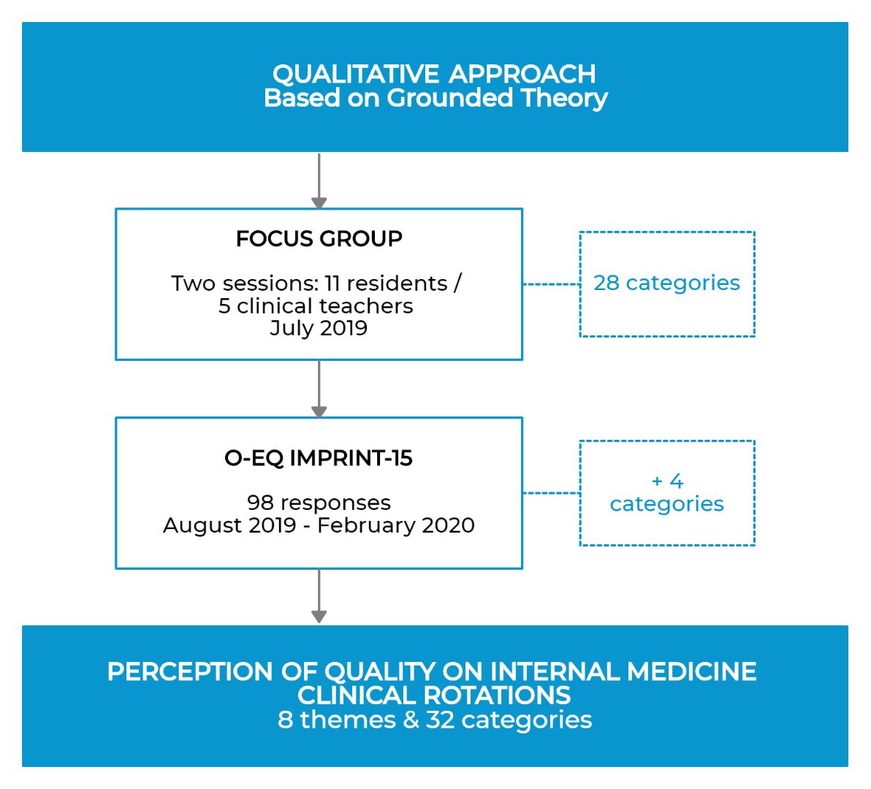
Figure 2.- Residents’ and Clinical Teachers’ Perceptions.

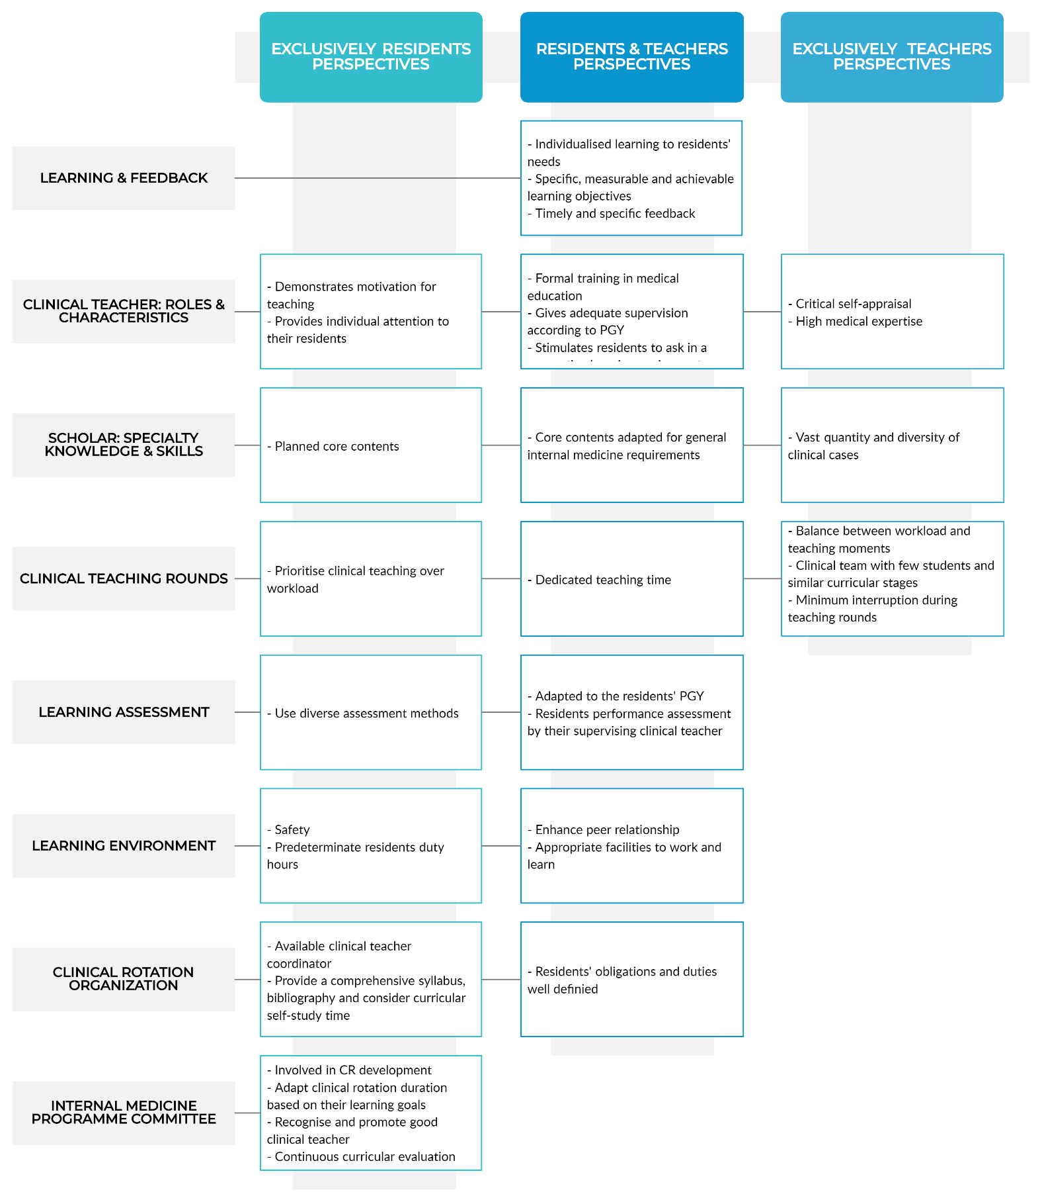
Figure 3.- Internal Medicine Clinical Rotation Framework. Key elements for a high-quality CR in Internal Medicine.

